**MAVEN**

Maven is an automation project tool developed by Apache. It is based on the Project Object Model (POM) and serves as a build tool that manages dependencies. Maven can compile and package multiple projects into desired output formats, such as JAR, WAR, and EAR files.

**MAVEN ARCHITECTURE**

The code will be extracted from GIT and pushed to Jenkin. Maven will add code and its dependencies. Then, the compiler will convert the code into a computer-known language, which will be called a jar or war file, depending on the code types.

**MAVEN BUILD LIFECYCLE**

* **mvn clean:** Cleans the project by removing files generated during the build.
* **mvn compile:** Compiles the source code of the project.
* **mvn test:** Runs the unit tests.
* **mvn package:** Packages the compiled code into a distributable format (e.g., JAR, WAR).
* **mvn install:** Installs the package into the local repository for use as a dependency in other projects.
* **mvn deploy:** Deploys the package to a remote repository for sharing with other developers.

**Maven configuration in Local:**

Creating a Project:

Check for maven installation in local. Create a directory somewhere and start a shell in that directory. On your command line, execute the following Maven goal:

**mvn archetype:generate -DgroupId=com.mycompany.app -DartifactId=maven-app -DarchetypeArtifactId=maven-archetype-quickstart -DarchetypeVersion=1.5 -DinteractiveMode=false**

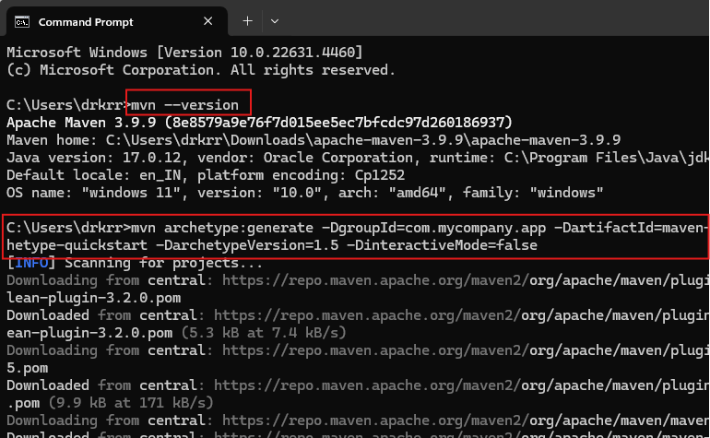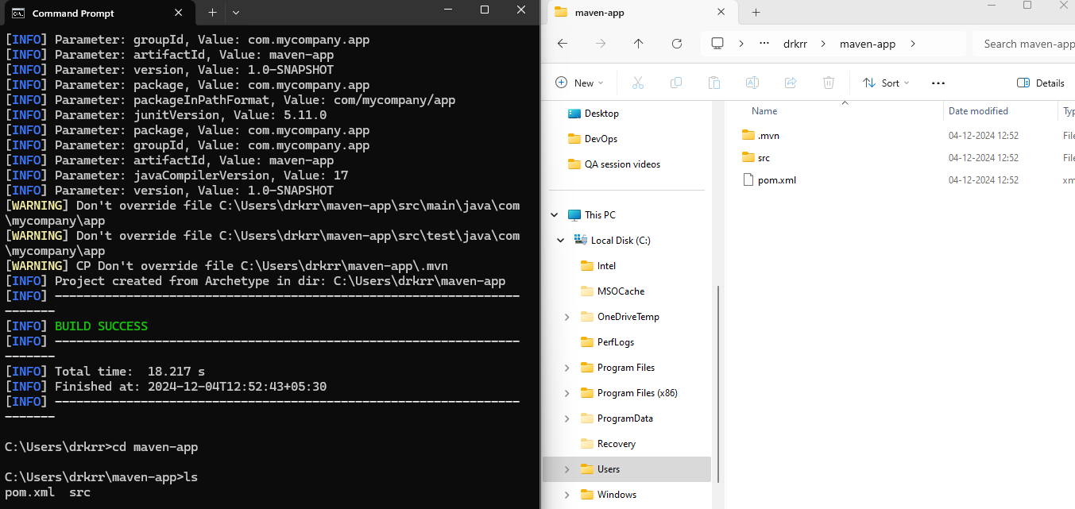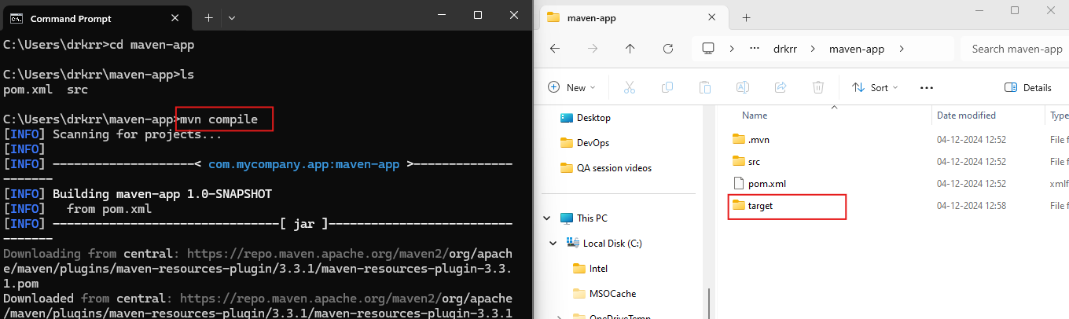

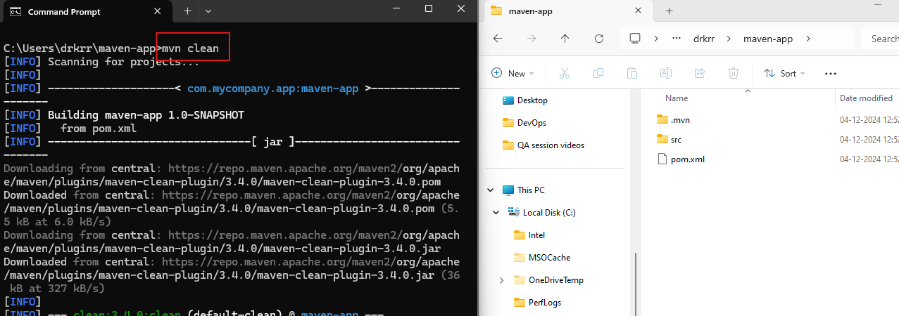

**Maven in Jenkins:**

Create a new job using freestyle project, in Build step provide the path and required command to run maven in Jenkins.

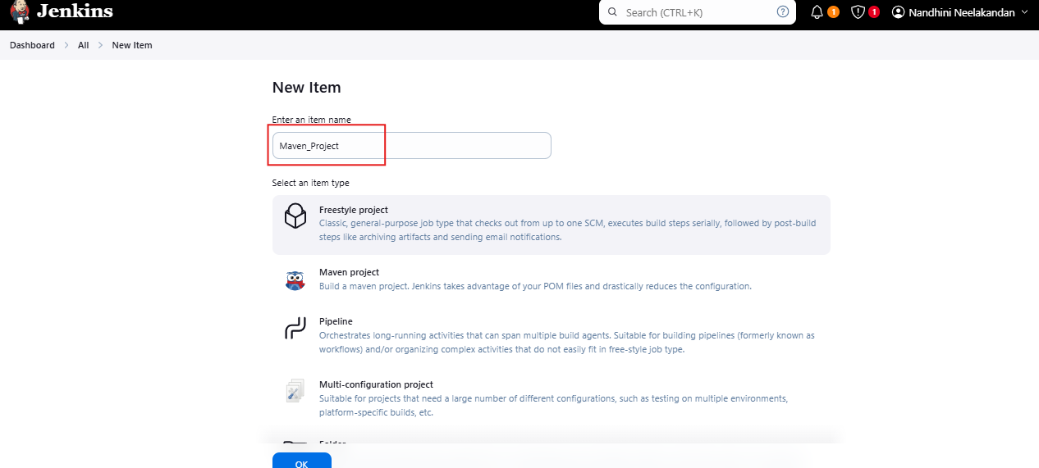

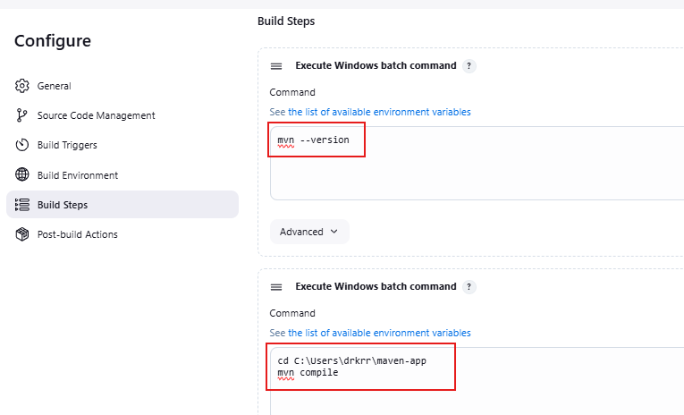

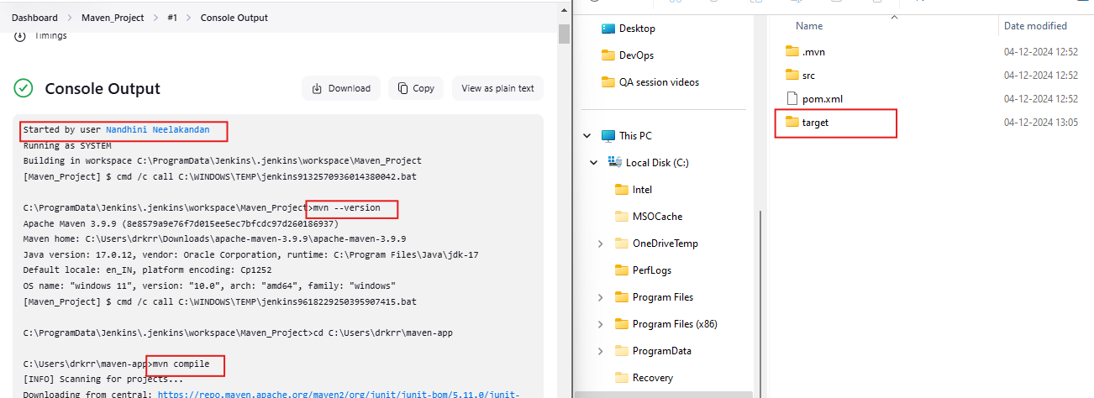

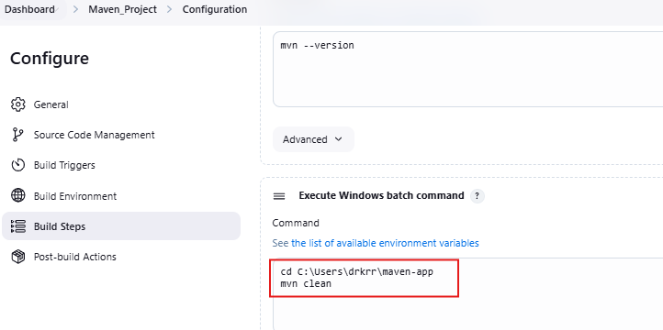

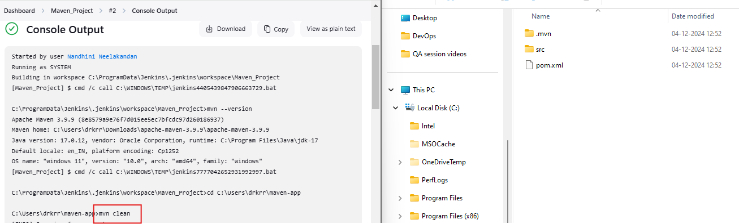

**Pushing files from local to Github:**

Connect to Your GitHub Repository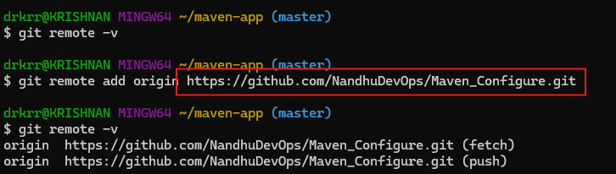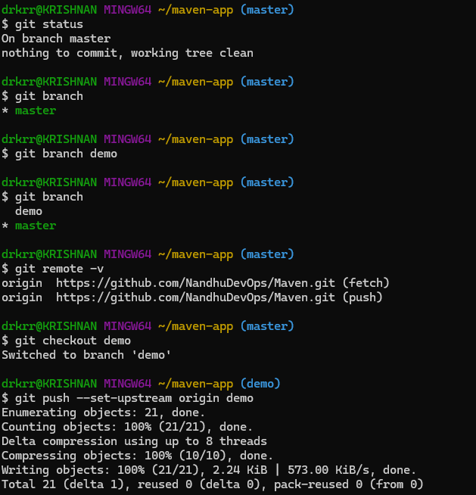

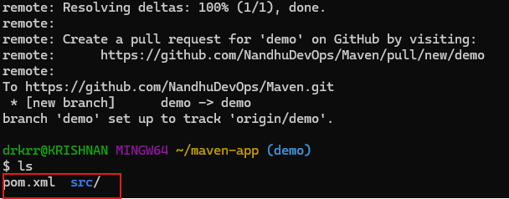

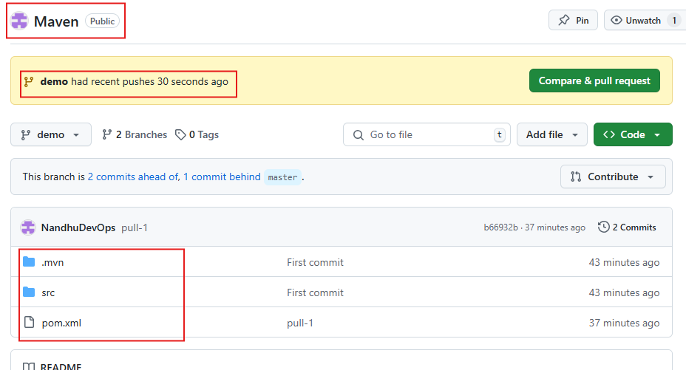

**MAVEN USING GIT SCM:**

Create a new job in freestyle project.

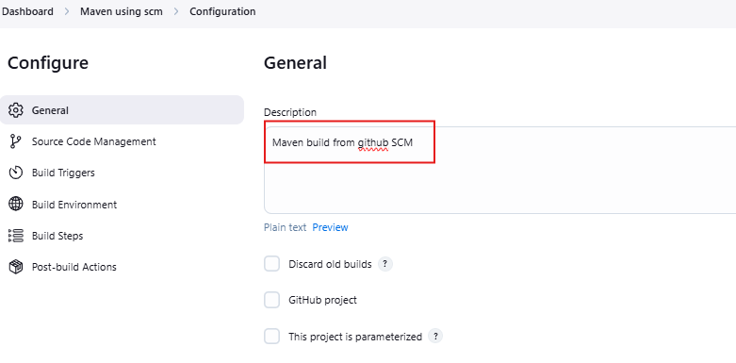

Link Local Repository to GitHub**:**

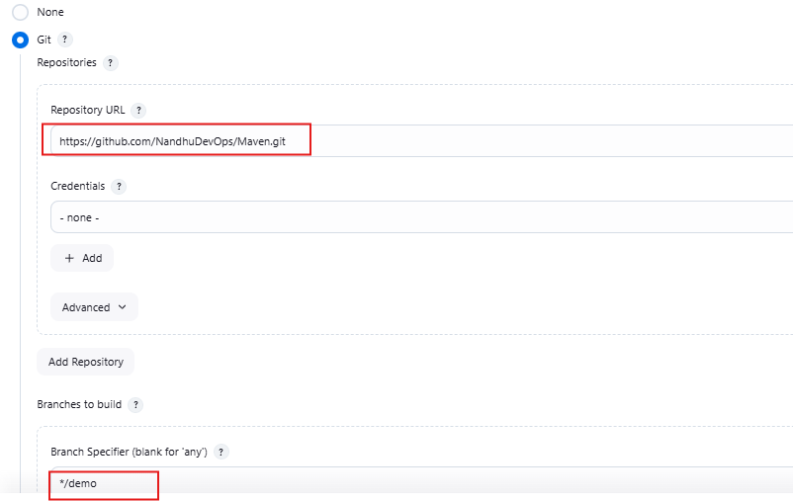

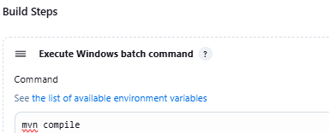

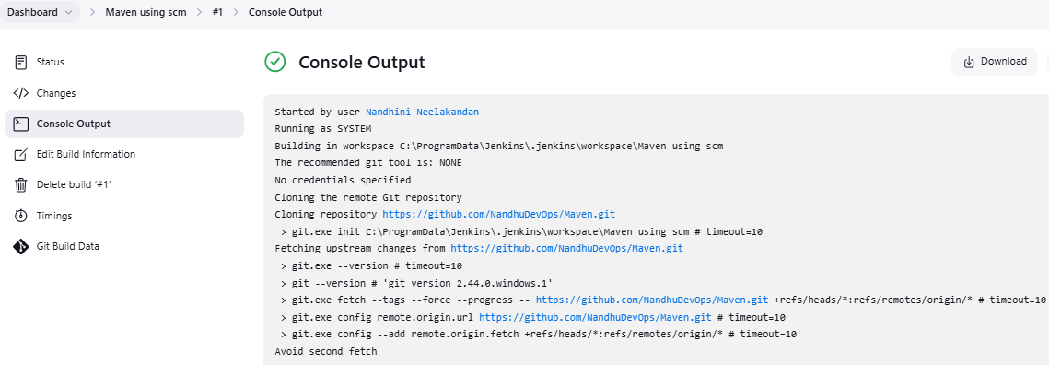

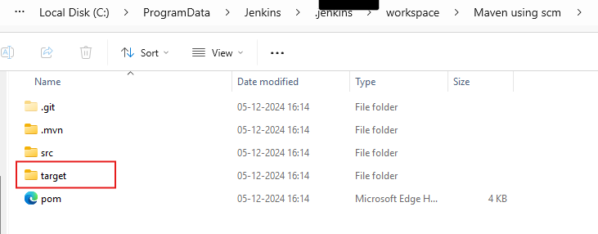

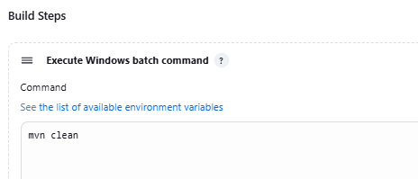

**Maven configuration using Pollscm to build:**

**POLL SCM:** Periodically check your source code for changes and trigger a build only if new changes are detected.

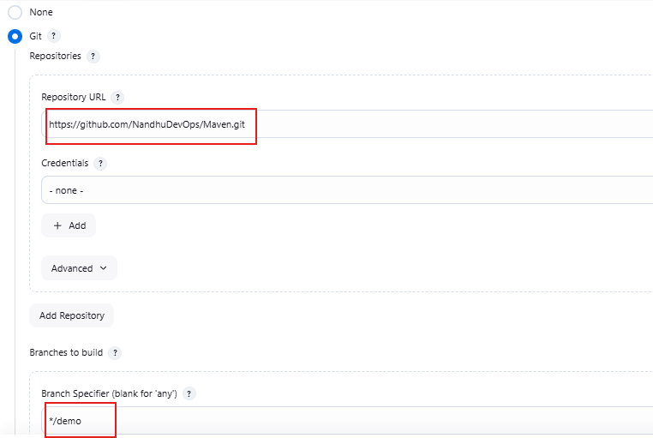

**Provide Email for mail notification after build.**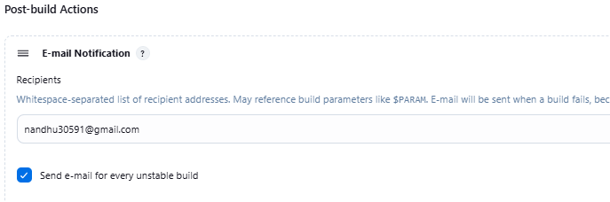

**Set a Poll scm to build job.**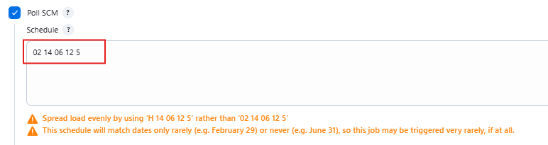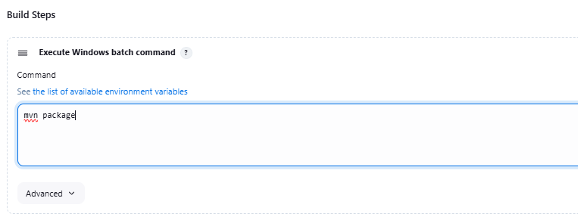

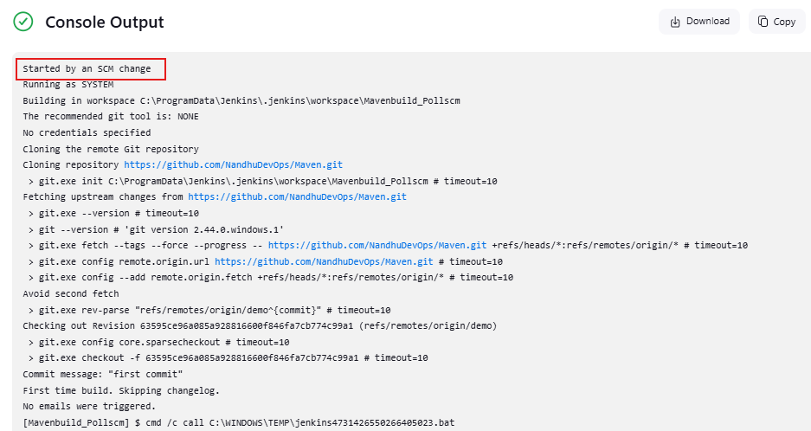

**Output in Jenkins directory:**

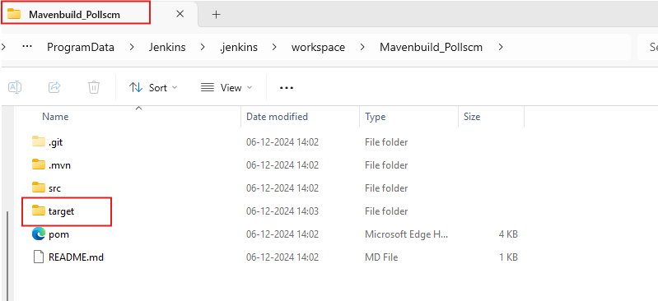

**Mail triggered for build 1:**

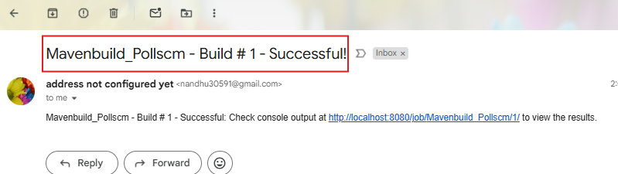

**Changes made in Github file to trigger Pollscm for build 2:**

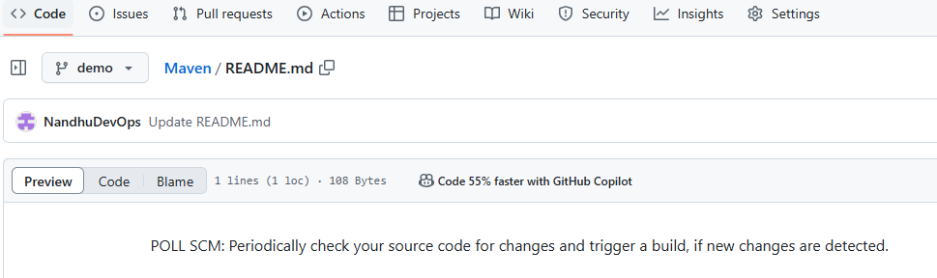

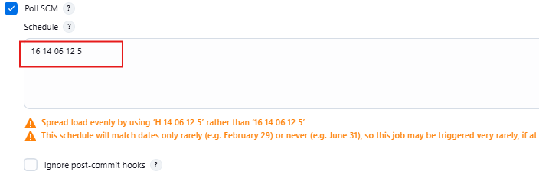

**Poll scm Output for build 2:**

